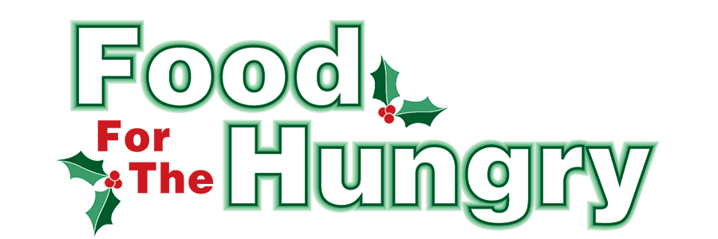

Contact Katelynn Mast
Food For The Hungry Marketing Director
(740) 485-9907
katmabe@mvnu.edu
November 29, 2022
FOR RELEASE ON NOV 29

HEADLINE: Local High School Drives for Food For The Hungry

MOUNT VERNON, Ohio — Knox County High Schools are set to launch their Food For The Hungry collections on November 29. Participating schools include Centerburg, East Knox, Danville, Mount Vernon, Fredericktown, and Knox County Career Center. Each High School is getting creative to collect food and funds for FFTH. The High School that collects the most will receive a winner’s plaque embellished with their name. Some schools are holding special assemblies for their students or donating admissions to sports games to FFTH collection.

The official start date for all High School drives is November 29. Each school has a different end date for its collection:
Fredericktown High School - December 2
Danville High School - December 6
Mount Vernon High School - December 7
Centerburg High School - December 8
Knox County Career Center - December 8.

All donations made within each school will stay within the local community. The school collections are always a significant contribution to the FFTH goal, signifying the age of someone does not limit generosity.

FFTH has set a goal of $250,000 for the 2022 campaign. You can get involved by donating online or at one of the 12 collection points throughout Knox County on Friday, Dec. 9. Visit www.FoodForTheHungryCares.org for continued opportunities to donate, volunteer, and find more information about upcoming events.
Food For The Hungry, celebrating over 40 Years of working together to care for our neighbors.
###

