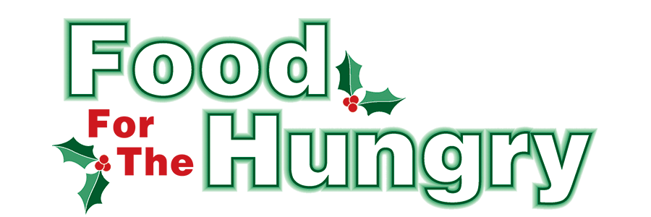

FOR IMMEDIATE RELEASE
Contact Katelynn Mast
Food For The Hungry Marketing Director
(740) 485-9907
katmabe@mvnu.edu
November 7, 2022

HEADLINE: The Knox Public Library continues donation campaign for Food For The Hungry

MOUNT VERNON — This year marks the 34th year of The Knox Public Library campaigning for Food For The Hungry. While The Knox Public Library is no longer charging fines, they are continuing to collect food and funds in support of the annual Food For The Hungry Drive from 11/7–12/3. The library branches participating include: Mount Vernon, Fredericktown, Danville, and Gambier.

Non-perishable items that are at or near their expiration dates, damaged, or in compromised containers will not be accepted. All collected food and money will be given to the 2022 Food For The Hungry drive. Donations from each community will stay in that local community. In addition to food items, the library will accept Humane Society approved brands of pet food.
Is there an event happening in the community in support of Food For The Hungry? Fill out the online Community Event Form on our website. Keep up to date with all events and donation totals on our Instagram and Facebook page. For more information on the 2022 Food For The Hungry Drive, to make a donation, or volunteer for this year’s campaign, go to foodforthehungrycares.org.
Food For The Hungry—Working together to care for our neighbors.

###

